BOUYANCY BAZOOKA: THE GRANDEST INVENTION EVER!!, DESIGNED BY A NIGERIAN

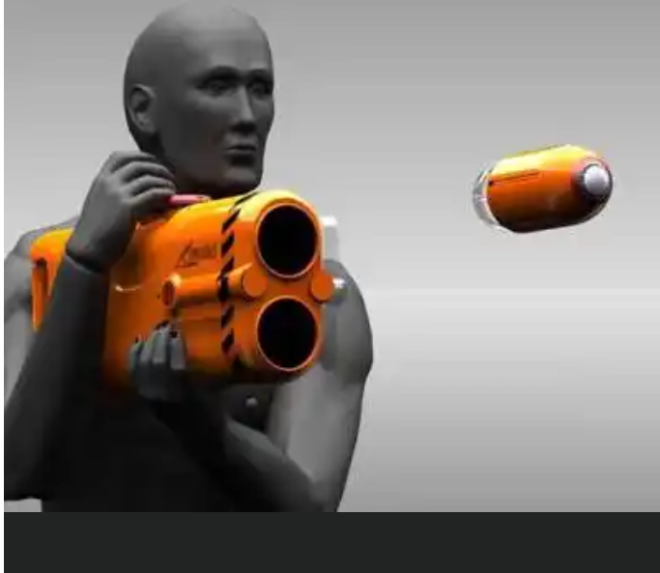
Designer Samuel Adeloju's clever little idea of a life-saving ring that can be "shot" out to a drowning victim beyond the reach of a simple toss, has won him A$16,000 in the James Dyson Award against 14 finalists. The international design award aims at inspiring young people to design something that solves a problem.
Given that Adeloju hails from surf-happy Australia, and is also a citizen of nigeria, one can guess at the inspiration floating his boat. The Longreach Buoyancy Deployment System works on the idea of a bazooka-like device that can fire a condensed bullet of hydrophobic foam up to 150m away, which then expands up to 40 times its size in water within a snappy 15 seconds. The kit is designed to be portable for carrying on boats and easy enough to employ in an emergency, thanks to printed instructions on it.

In case you're a lousy shot or there are more victims at sea, this carries two shots with a fast reload action. And in the event it's dark, this packs on Para-Flares for nighttime illumination.

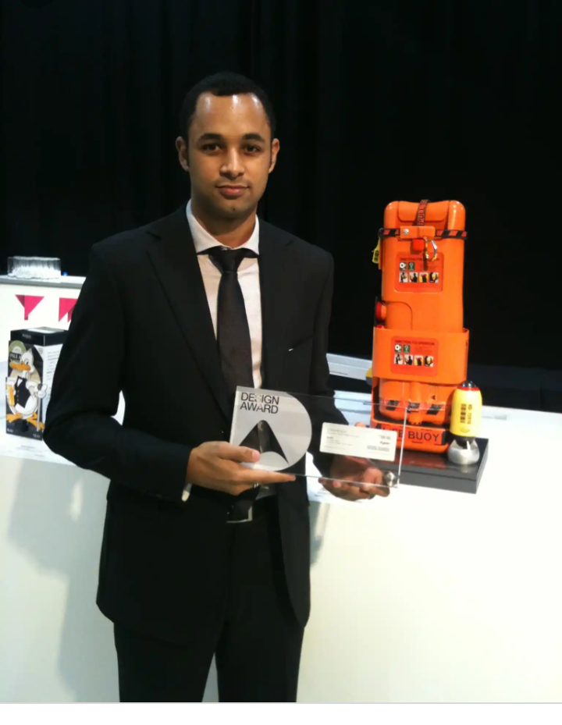
The good news is that the Longreach Buoyancy Deployment System won't end up relegated to drawing board hell like so many other concepts. This is slated for actual field trials Down Under come the next few months, and it won't surprise us if it pops up on seafaring boats in the near future.

CODE - Bahamas7

